Maya setup
Installation of the CryEngine tools plugin
Please navigate to the following folder, where you'll find the installation instructions in the Readme file.
Maya plugin files are located here: KCD2Mod\Tools\modding\Maya\plugin
Manual Installation
Move the ./plugin/MayaCryExport folder and ./plugin/MayaCryExport.mod file to
\<user>\Documents\maya\<version>\modules
You might have to create the "modules" folder if it does not exist.
This plugin only supports Maya 2022, 2024, and 2025 in win64.
1. Run the <root>\Tools\SettingsMgr.exe and setup the path to your build. See the Settings Manager article on how to do this:
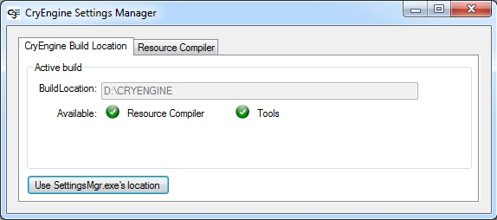
2. In Maya make sure that the 'MayaCryExport2%MAYAVERSION%.mll' plugin is loaded in Plugin Manager.
Go to Windows -> Settings/Preferences -> Plug-in Manager.
Use the browse button and load the plugin directly from your <root>\Tools\maya\plugins\ folder.
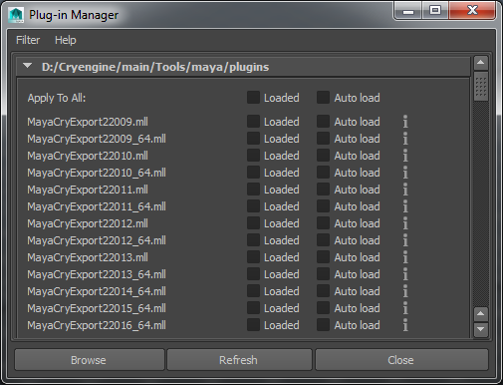
3. Once loaded, Maya may have to be restarted for the Exporter to work.
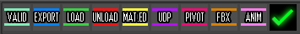
Tools, Material and Export dialog
